**INFORMATION LETTER**

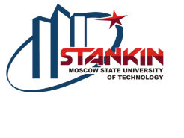

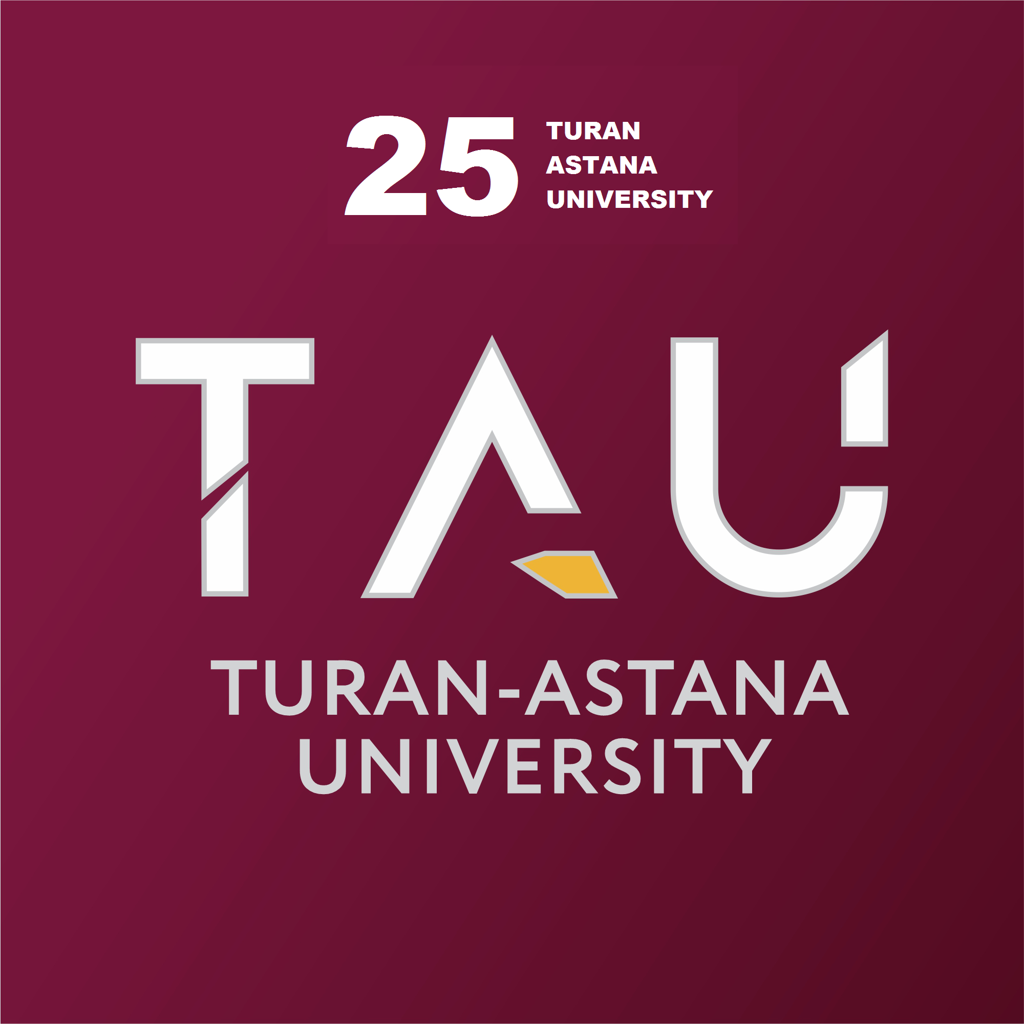

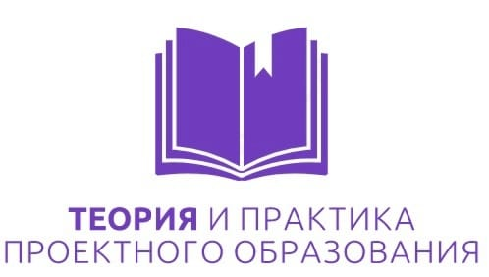



***Dear teachers, doctoral students, undergraduates and students!***

We invite you to take part in the International Scientific and Practical Conference of the teaching staff, doctoral students, undergraduates and students

"INTEGRATION OF SCIENCE AND PRACTICE - A MECHANISM FOR THE EFFECTIVE DEVELOPMENT OF MODERN SOCIETY"

**PLACE AND TIME OF THE CONFERENCE**

The conference is organized and conducted by TURAN-ASTANA UNIVERSITY (Kazakhstan, Astana) in a mixed format (April 27-28, 2023)

**THE ORGANIZERS AND PARTNERS OF THE EVENT WERE:**

Moscow State Technological University "STANKIN";

Moscow Polytechnic University;

Central Research Institute of Russian Sign Language;

Student Scientific Society of the Higher School of State Audit of Lomonosov Moscow State University;

with the informational support of the scientific and methodological journal "Theory and practice of project education".

On April 27-28, 2023, Turan-Astana University will host an international scientific and practical conference of students, undergraduates and doctoral students dedicated to the 25th anniversary of Turan-Astana University - "Integration of science and practice - a mechanism for the effective development of modern society".

An international competition of scientific and practical works and projects is held within the framework of the conference.

The Organizing Committee invites participants to submit the project for evaluation before an expert jury.

The purpose of the conference is to create a platform for professional self-realization of the teaching staff and young researchers and their participation in solving urgent problems of a regional and global nature.

The objectives of the conference are to consider new scientific and practical results of the use of innovative technologies in science, education and production; exchange ideas, search for joint directions for further research, strengthen cooperation between educational, scientific and industrial organizations; establish new contacts and attract young people to scientific research.

Participation in the conference is a further excellent opportunity for the teaching staff and young researchers to test their scientific achievements in the field of science and education.

The following sections are planned to work at the conference:

|  |  |
| --- | --- |
| **№** | **Section name** |
| 1 | Integration of science, education and production: problems, achievements, innovations |
| 2 | Development of digital technologies to increase business efficiency |
| 3 | Topical issues of modern jurisprudence: theory and practice |
| 4 | Actual problems of social and humanitarian science |
| 5 | Trends in the development of design, service and tourism business |
| 6 | Tribune of Young Researchers |

**The working languages of the conference are Kazakh, Russian, and English.**

The text of the report with a volume of 4-7 pages should be typed in the MicrosoftWord editor, TimesNewRoman font 14, line spacing – 1, all fields:– 2 cm. Paragraph - 1 cm. The collection of conference materials will be published after the conference.

The reports will be typed by direct copying. We draw your attention to the need to provide the article in a carefully edited form. The author is responsible for the content of the article. The Organizing Committee reserves the right to reject materials that do not correspond to the topics of the conference sections, materials of the abstract plan, articles sent after the deadline or issued in violation of the requirements set out in this letter.

The deadline for submitting reports is April 15, 2023.

Send the completed article to the following email address: smoilovs@mail.ru

The registration fee for the publication of the article is 2000 tenge for students.

**Bank account details:**

**BIN** 031140004668

**IIK** KZ636017111000012140 (KZT)

**BIK** HSBKKZKX

Halyk Bank of Kazakhstan JSC

KbeК 17 KNP-861

Purpose of payment: For participation in the conference "Integration of science and practice - a mechanism for the effective development of modern society"

Organization: Turan-Astana University. Address: 010000, Nursultan, ul. Y.Dukenuly, 29. Contact phone numbers:8-705-397-57-55 Smolov Samat Zhumagalievich, PhD, Vice Provost for Science and Innovation

*Sample design: PLEASE STRICTLY OBSERVE!!!*

**УДК 343.13**

Bazarbay Meiram Zhakenovich

Master's student of the Department"national and international law"

Turan-Astana University

Nur-Sultan, Republic of Kazakhstan

Scientific supervisor:

candidate of Law, Associate Professor Karymsakov R. Sh.

**ҚЫЛМЫСТЫҚ ПРОЦЕСТЕГІ ЖАСЫРЫН ТЕРГЕУ ӘРЕКЕТТЕРІН ЖҮРГІЗУДІҢ ШАРТТАРЫ**

**УСЛОВИЯ ПРОВЕДЕНИЯ НЕГЛАСНЫХ СЛЕДСТВЕННЫХ ДЕЙСТВИЙ В УГОЛОВНОМ ПРОЦЕССЕ**

**CONDITIONS FOR CONDUCTING SECRET INVESTIGATIVE ACTIONS IN CRIMINAL PROCEEDINGS**

**Аннотация:** (30 слов)

**Түйінді сөздер:** (5 слов)

**Аннотация:** (30 слов)

**Ключевые слова:**(30 слов)

**Abstract:**(30 words)

**Keywords:** (5 words)

Conditions for conducting covert investigative actions – the irrefutable implementation of covert investigative actions creates conditions for the development and implementation of exactly one operational investigative action, which is called upon to increase their effectiveness in conducting covert investigative actions and guarantee compliance with the principles of operational investigative activities special provisions established by operational investigative laws. [1].

The organization and tactics of conducting secret secret investigative actions may constitute official, military and state secrets in accordance with the list of information subject to declassification, approved by the Government of the Republic of Kazakhstan on March 15, 1995 on the basis of the law of the Republic of Kazakhstan "on state secrets".

**Used literature:**

1 Under the general editorship of K.K. Goryainov, V.S. Ovchinsky, G.K. Sinilova, A.Y. Shumilova. Operational and investigative activities. Textbook. Moscow, 2004, 302-bet.

2 Nurakhmetov T.N.. Problems of morality in the activities of employees of national security agencies. - Almaty, “Zhetizhargy, 2006, - p. 79.

3 V. Pletnev. Operational and investigative activities. The course of the lecture. Almaty, 2001, 106-bet.